Patient Instructions
Donjoy Shoulder Immobilizer

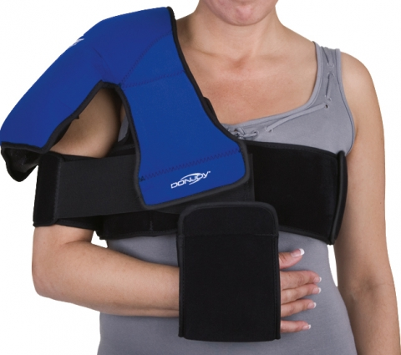
Application Instructions:

- Take the chest straps and attach them together where it says injured side
- Place the injured side under the injured shoulder and then attach the straps together on the uninjured side
- Take the blue shoulder pad and attach the corresponding right or left tab(found on the chest strap) to the blue shoulder piece
- Take the biceps strap and attach it just underneath the blue shoulder pad (middle of the upper arm)
- Make sure that the long Velcro strap is in the back and attach it onto the chest strap
- Attach the short Velcro piece onto the front of the chest strap.
- Attach the “sling” by undoing the Velcro and attaching it to the bottom of the chest strap on the affected side.
Removal:

- For easy removal undo the biceps strap from the chest piece (front and back)
- Undo the bicep strap and remove
- Undo the chest strap on the unaffected side and slide the cryo down the arm and remove

Tips:

- Once assembled to reapply slide the cryo up the arm and attach the chest strap into place on the unaffected side
- Attach the biceps strap on making sure the long strap is in the back and attach it to the chest strap then attach the short strap to the front of the chest strap

